'Programmer: Samantha Naini
'Exercise: 5-1-15
'Date: 4/16/2012
'Program purpose: To calculate a person's BMI via weight and height inputs.

Option Strict On
Option Explicit On

Public Class frmBMI

Private Sub btnCompute_Click(ByVal sender As System.Object, ByVal e As System.EventArgs) Handles btnCompute.Click
Dim Weight As Double = CDbl(txtWeight.Text)
Dim Height As Double = CDbl(txtHeight.Text)
txtOutput.Text = CStr(BMI(Weight, Height))

If txtOutput.Text > 19 And txtOutput.Text < 25 Then
txtStatus.Text = "You are at a healthy weight."
ElseIf txtOutput.Text < 19 Then
txtStatus.Text = "You are underweight."
Else
txtStatus.Text = "You are overweight."
End If

End Sub

Function BMI(ByVal w As Double, ByVal h As Double) As Double
Return Math.Round((703 * w) / (h ^ 2))
End Function

Private Sub btnClear_Click(ByVal sender As System.Object, ByVal e As System.EventArgs) Handles btnClear.Click
txtWeight.Clear()
txtWeight.Focus()
txtHeight.Clear()
txtOutput.Clear()
txtStatus.Clear()
End Sub

Private Sub btnEnd_Click(ByVal sender As System.Object, ByVal e As System.EventArgs) Handles btnEnd.Click
If MsgBox("Do you really want to quit?", MsgBoxStyle.YesNoCancel, "End Program") = MsgBoxResult.Yes Then
MsgBox("have a great day! =)")
Me.Close()
End If
End Sub
End Class
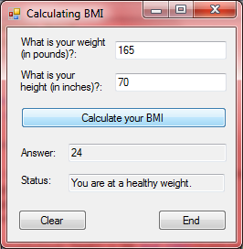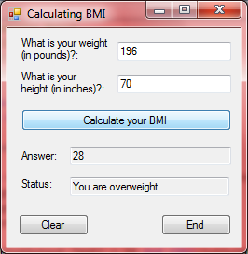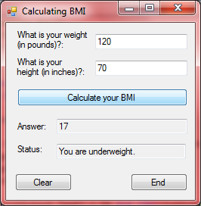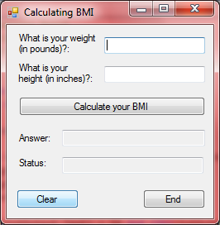←Clear button
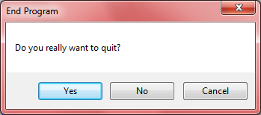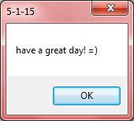←End button
'Programmer: Samantha Naini
'Date: 4/18/2012
'Exercise: 5-1-16 pg. 173
'Program Purpose: Computing someone's training heart rate

Option Strict On
Option Explicit On

Public Class frmTrainingHeartRate

Function FindTrainingHeartRate(ByVal Age As Double, ByVal RHR As Double) As Double
Dim MaxHR As Double
MaxHR = 220 - Age
Return (MaxHR - RHR) * 0.6 + RHR
End Function

Private Sub btnCompute_Click(ByVal sender As System.Object, ByVal e As System.EventArgs) Handles btnCompute.Click
Dim Age, RHR, THR As Double

Age = CDbl(txtAge.Text)
RHR = CDbl(txtRHR.Text)

THR = Math.Round(FindTrainingHeartRate(Age, RHR))

txtTHR.Text = "Your training heart rate is " & THR & "."
End Sub

Private Sub btnClear_Click(ByVal sender As System.Object, ByVal e As System.EventArgs) Handles btnClear.Click
txtAge.Clear()
txtAge.Focus()
txtRHR.Clear()
txtTHR.Clear()
End Sub

Private Sub btnEnd_Click(ByVal sender As System.Object, ByVal e As System.EventArgs) Handles btnEnd.Click
If MsgBox("Do you really want to quit?", MsgBoxStyle.YesNoCancel, "Quit!") = MsgBoxResult.Yes Then
MessageBox.Show("Have a great day! =)")
Me.Close()
End If
End Sub
End Class
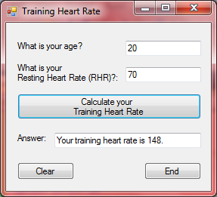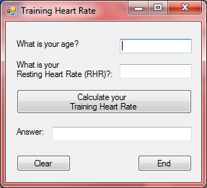←Clear
My Training Heart Rate:
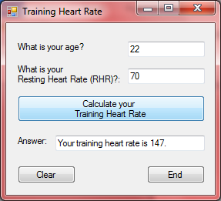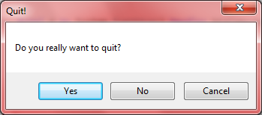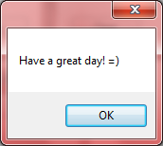←End
'Programmer: Samantha Naini
'Date: 4/18/2012
'Exercise: 5-2-34 (pg.188)
'Program Purpose: To compute a person's tip based on their occupation, amount of the bill, and percentage of the tip.

Option Strict On
Option Explicit On

Public Class frmGratuities

Function GetTip(ByVal Bill As Double, ByVal Tip As Double) As Double
Return Bill * (Tip / 100)
End Function

Private Sub Button1_Click(ByVal sender As System.Object, ByVal e As System.EventArgs) Handles btnCompute.Click
Dim Occupation As String
Dim Bill, Tip, Result As Double

Occupation = CStr(txtOccupation.Text)
Bill = CDbl(txtBill.Text)
Tip = CDbl(txtPercentTip.Text)

Result = Math.Round(GetTip(Bill, Tip))

txtOutput.Text = "You should tip the " & Occupation & " " & FormatCurrency(Result) & "."
End Sub

Private Sub btnClear_Click(ByVal sender As System.Object, ByVal e As System.EventArgs) Handles btnClear.Click
txtOccupation.Clear()
txtBill.Clear()
txtOccupation.Focus()
txtPercentTip.Clear()
txtOutput.Clear()
End Sub

Private Sub btnEnd_Click(ByVal sender As System.Object, ByVal e As System.EventArgs) Handles btnEnd.Click
If MsgBox("Do you really want to quit?", MsgBoxStyle.YesNoCancel, "Quit!") = MsgBoxResult.Yes Then
MessageBox.Show("Have a great day! =)")
Me.Close()
End If
End Sub

End Class
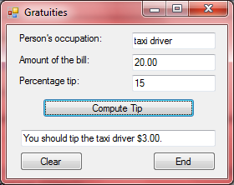 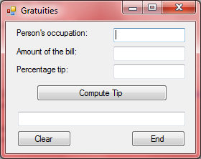←Clear
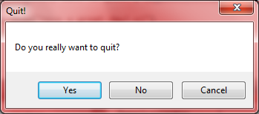 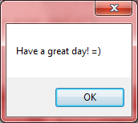←End
'Programmer: Samantha Naini
'Date: 4/18/2012
'Exercise: 5-2-36 (pg. 188)
'Program Purpose: To display someone's letter grade by calculating the average of three numeric grades.

Option Strict On
Option Explicit On

Public Class frmSemesterGrades

Function CalculatedGrade(ByVal FirstGrade As Double, ByVal SecondGrade As Double, ByVal ThirdGrade As Double) As String

Dim LowestGrade As Double, NumericGrade As Double
Dim GradeLetter As String = Nothing

LowestGrade = GetLowest(FirstGrade, SecondGrade, ThirdGrade)
NumericGrade = (FirstGrade + SecondGrade + ThirdGrade - LowestGrade) / 2

Select Case Math.Round(NumericGrade)
Case 90 To 100
GradeLetter = "A"
Case 80 To 89
GradeLetter = "B"
Case 70 - 79
GradeLetter = "C"
Case 60 To 69
GradeLetter = "D"
Case 0 To 59
GradeLetter = "F"
Case Else
GradeLetter = "Invalid"
End Select

Return GradeLetter
End Function

Function GetLowest(ByVal FirstGrade As Double, ByVal SecondGrade As Double, ByVal ThirdGrade As Double) As Double
Dim LowestGrade As Double
LowestGrade = FirstGrade

If SecondGrade < LowestGrade Then
LowestGrade = SecondGrade
End If
If ThirdGrade < LowestGrade Then

LowestGrade = ThirdGrade
End If

Return LowestGrade
End Function

Private Sub DisplayGrade(ByVal Name As String, ByVal FirstGrade As Double, ByVal SecondGrade As Double, ByVal ThirdGrade As Double)

Dim GradeLetter As String

GradeLetter = CalculatedGrade(FirstGrade, SecondGrade, ThirdGrade)
txtOutput.Text = "" & Name & ": " & GradeLetter & ""
End Sub

Private Sub btnCompute_Click(ByVal sender As System.Object, ByVal e As System.EventArgs) Handles btnCompute.Click
Dim Name As String
Dim FirstGrade, SecondGrade, ThirdGrade As Double

Name = CStr(txtName.Text)

If IsNumeric(txtFirstGrade.Text) And IsNumeric(txtSecondGrade.Text) And IsNumeric(txtThirdGrade.Text) Then

FirstGrade = CDbl(txtFirstGrade.Text)
SecondGrade = CDbl(txtSecondGrade.Text)
ThirdGrade = CDbl(txtThirdGrade.Text)
End If

DisplayGrade(Name, FirstGrade, SecondGrade, ThirdGrade)
End Sub

Private Sub btnClear_Click(ByVal sender As System.Object, ByVal e As System.EventArgs) Handles btnClear.Click
txtName.Clear()
txtName.Focus()
txtFirstGrade.Clear()
txtSecondGrade.Clear()
txtThirdGrade.Clear()
txtOutput.Clear()
End Sub

Private Sub btnEnd_Click(ByVal sender As System.Object, ByVal e As System.EventArgs) Handles btnEnd.Click
If MsgBox("Do you really want to quit?", MsgBoxStyle.YesNoCancel, "Quit!") = MsgBoxResult.Yes Then
MessageBox.Show("Have a great day! =)")
Me.Close()
End If
End Sub

End Class
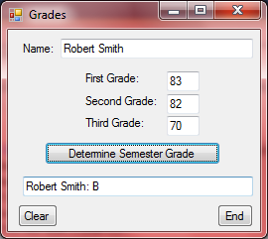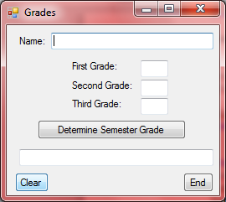
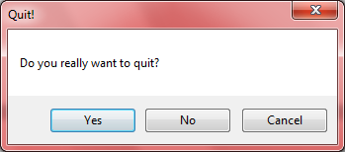 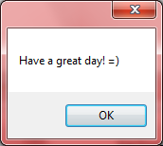←End

